

End User Guide

Contents
Overview of Bengal Buy 3
Understanding and Accessing Bengal Buy 3
Site Navigation 4
Setting Up Your Profile for the First Time 5
Changing Your Notification Preferences 7
Shopping Overview 7
Method 1-Catalog Orders 7
Method 2-Non-Catalog Orders 8
Method 3-Special Requests 9
Cart Management 10
Purchase Requisitions Navigation and Overview 10
Searching Order Status 12
Receiving 13
Creating a Receiver 14
New Supplier Process 15
Tip and Tricks 15
Glossary of Terms 17

Overview of Bengal Buy
Bengal Buy is our new shopping environment and electronic requisitioning, payment, and receiving system. It provides a completely electronic and paperless workflow for purchase requisitions, purchase orders, receiving, and payment vouchers, and improves efficiency by allowing State and Research Foundation orders to be processed efficiently while providing campus departments to access all documents, within a single system.
At its core Bengal Buy is an online requisition/purchasing tool. When users shop, items are routed through various stages: From shopping, through any necessary approvals, with the resulting purchase order being sent to the supplier, the commodities being received, and then the account being payable to the supplier. Here is a sample workflow:
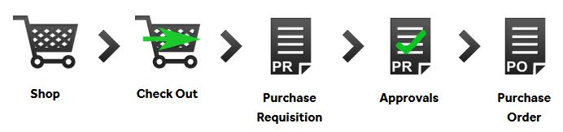
The two (2) primary user roles in Bengal Buy are Requester and Approver. Your access depends on your role. Because of these roles, a purchase may go through multiple people before officially becoming a Purchase Requisition.
- Requester - Can “shop” by creating a shopping cart. Complete the accounting information and submit the “cart” for Authorized Signatory approval.
- Approver - Can do everything a Requester can do, plus they are responsible for reviewing each requisition, requesting more information if required, and approving or rejecting requisitions as needed.

Understanding and Accessing Bengal Buy
Bengal Buy can be accessed from Purchasing’s Website or by going to the following link: BENGAL BUY eProcurement System (PROD)
https://idm.suny.edu/fed/idp/initiatesso?providerid=https://solutions.sciquest.com
Bengal Buy is integrated with campus SSO (single sign-on), so you will need to use your Campus user ID and password. If you are accessing Bengal Buy for the first time, please make sure you have reached out to Purchasing if you run into any issues.

Site Navigation
The user interface is designed to provide an easy and intuitive experience. The site is user friendly in its navigation and has several features to help locate and manage tasks. Some of the menu items and features may not be seen by all users, due to your access and functions.
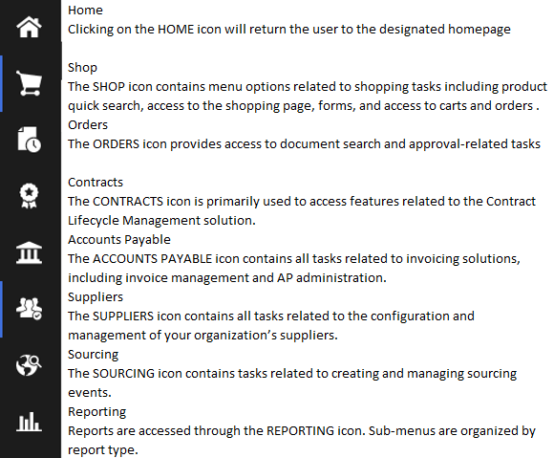

Setting Up Your Profile for the First Time
After the initial set up of your profile, default settings should be saved for all future orders and work in Bengal Buy.
- Viewing your profile: From Homepage, Click on Profile Icon in top right corner and click on “View My Profile” in the drop-down menu.

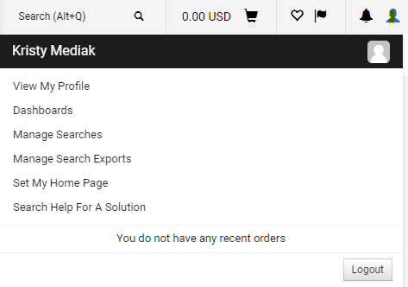

- Most information in the first section, User’s Name, Phone Number, Email, etc., may have been prefilled and unable to be edited. Update any information as needed. If any information that cannot be edited is incorrect contact your Bengal Buy Campus Administrator via email to Purchasing@buffalostate.edu. Please be sure to always use ‘Bengal Buy’ in the subject line of any email.

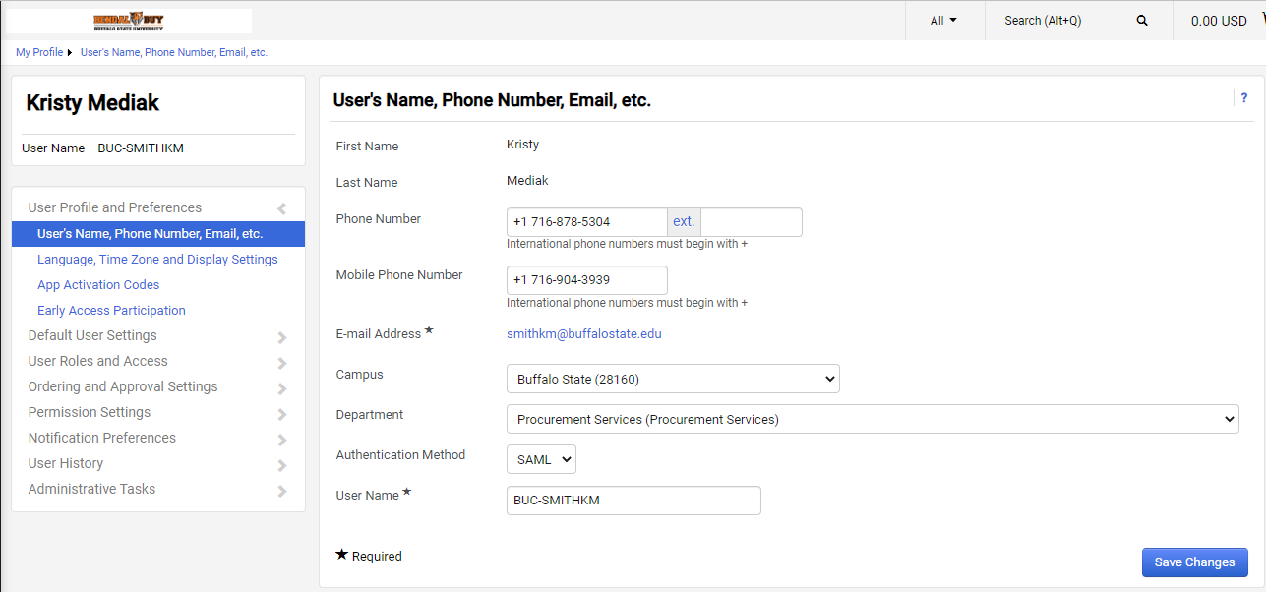

- Please update any information in the “Language, Time Zone and Display Settings” section. If there are prefilled/default selections, please leave those as is.
- You do not need to complete the “Early Access Participation” or “App Activation Codes”
- Under Default User Settings, select Default Addresses, there are two tabs for “Ship To” and “Bill To”. Under each tab, click on “BuffSt-Campus Default.’
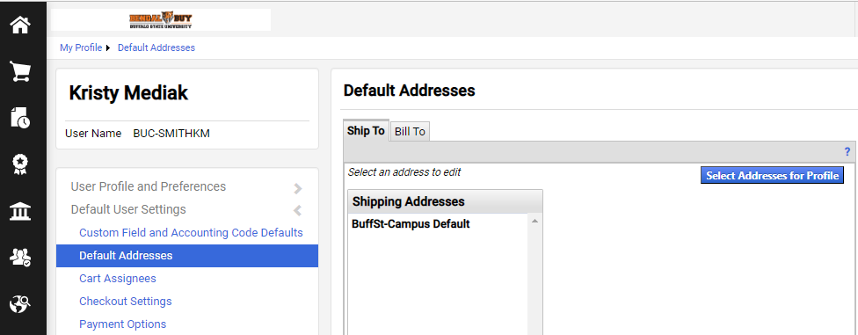

- Under Ship To: update the Attention line to your full name, as well as the Building line to your specific campus building and room number. This will ensure the order is delivered to your campus location.
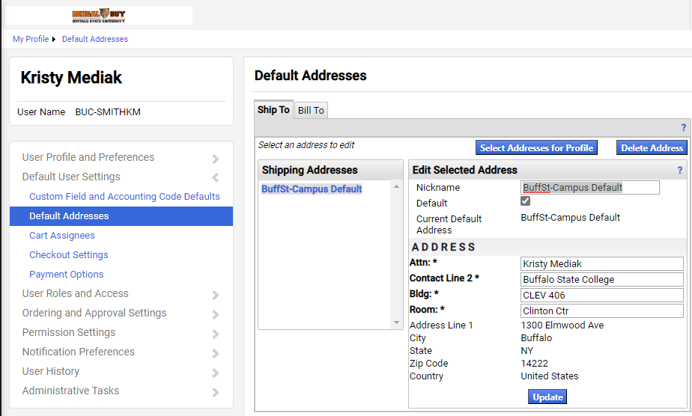

- Under Bill To: Ensure the default BuffSt-Billto-State is selected as below, and click Update. All orders, regardless of funding source, will be automatically billed by the supplier to Accounts Payable.
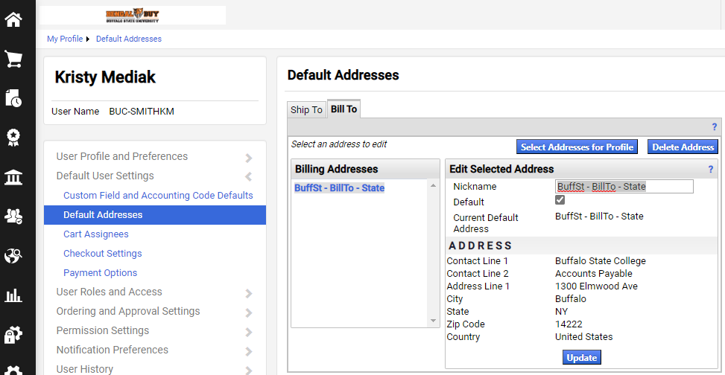

Changing Your Notification Preferences
Each user can customize various in-application functions by changing their Notification Preferences. As we become more familiar with Bengal Buy, users may change their preferences, to reduce the amount of emails they receive from Bengal Buy. It is recommended that all users receive EMAIL notifications initially.
To change your preferences, in View My Profile on the left then select Notification Preferences. Each user’s Notification Preference choices will vary depending on their Bengal Buy “role(s).” Select the notification category you would like to change, such as Shopping, Carts & Requisitions, – Make sure you click “Edit Selection” on the upper right hand side.
Click “Override” on any in-application functions you would like to customize. Using the dropdown arrow to the right of “Override”, select the type of notification you would like to receive.
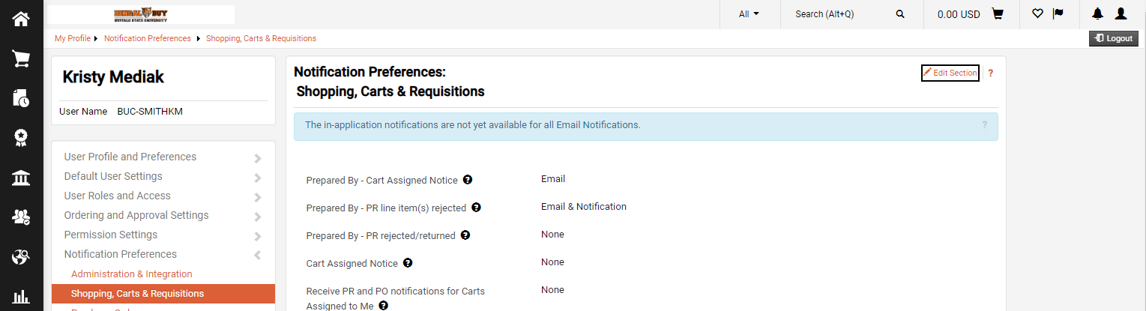

Shopping Overview
There are three ways to create orders in Bengal Buy. Users can submit a catalog order, non-catalog item order, and special requests. This section will provide detail on these different order types so users can have a better understanding of what they are and which order type to use.
Choosing a Method:
- The first step is determining if the items you need to purchase are available with one of the eMarketplace catalog suppliers. This can be done by shopping on a Hosted Catalog, Punch-out Catalog or by using the Shop Search. Available suppliers are listed in the Showcases section of your home screen.
- If the items or services you are purchasing are not catalog items and do not meet the form criteria, you will need to create a Non-Catalog Item order.
- If the items/services you need are neither catalog or non-catalog orders, you will need to use a Form. These forms are available in the Special Request Section of the home screen and include Standing Order Request, Honorarium Request, or Special Request.

Method 1-Catalog Orders
Catalog Orders - A catalog is a supplier’s product offering. There are two types of catalogs, hosted and punch-out. These are described below.
- Hosted Catalog – In simplest terms, a hosted catalog is an online version of a supplier’s printed catalog. Hosted catalogs contain product data and details, along with pricing information for each item. When a product search is performed, the products in all the hosted catalogs are searched. Hosted catalog search results contain product information from all suppliers depending on the search criteria entered by the user.
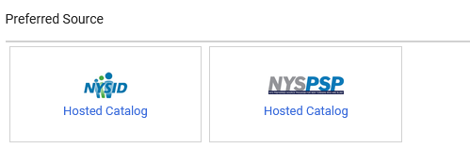
- Punch-out Catalogs – Punch-out catalogs are integrated external links to a supplier’s web-based catalog. The user exits the application to search and select products from a supplier’s web catalog, then returns the items to the BENGAL BUY shopping cart. The selected items are then submitted through the standard requisition/order process.

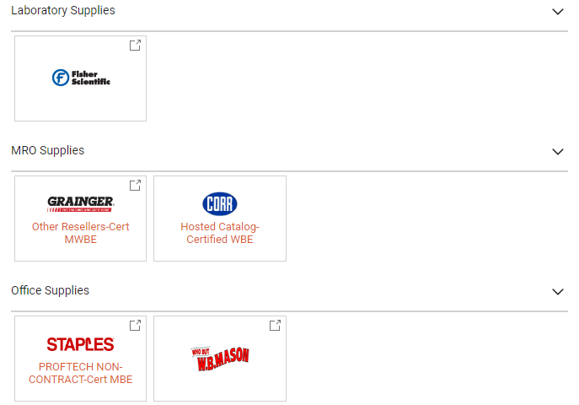

Method 2-Non-Catalog Orders
Non-Catalog Item Orders – A non-catalog item order is an order for goods or services where there is not a catalog available in Bengal Buy for these goods or services. This is a purchase that there is no State Contract. Note that almost all purchases that are not purchased as a Catalog Order will be purchased using this method.
When searching for the supplier within the system, you will always select the bolded vendor address as shown below:
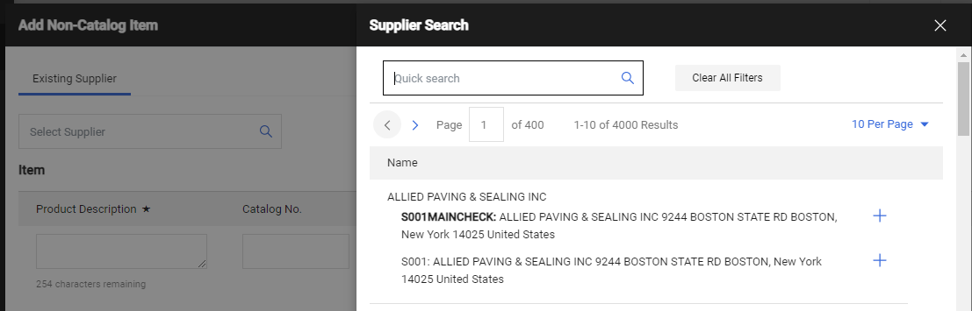

Method 3-Special Requests
Special Requests – Special Requests are for specific types of orders or payments. Bengal Buy does not convert Special Request forms into an external order. Special Request forms are only allowable for the below types of purchases:
- Arbitration Fees
- Certifications and Accreditations
- Program accreditation
- Professional Certification
- Emergencies (Health & Safety)
- Memberships or Associations
- NYS Construction Advertising
- Registrations for Conferences
- Subscriptions for Periodicals (E.G. Buffalo News)
- Utilities
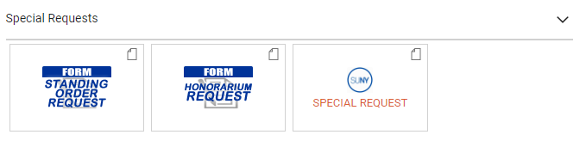
- Standing (Blanket) Order Request – This form is used to create orders that will (normally) be open for the entire fiscal year (July 1 through June 30). Departments and Buyers will work together to establish an annual encumbrance amount, based on the prior 2-3-year average. This form will create and send an external order to the supplier and encumber the expense.
- Honorarium Request - This form is used for payments to lecturers, guest speakers and any individual performing a service for our campus. Honorariums are a one-time payment for short-duration service (usually just one day, but not to exceed four consecutive days) and relatively small dollar amount (generally under $2,500). An honorarium is an ex-gratia payment (i.e. the University has no obligation or liability to pay it); honorarium payments may not be used for the services of an independent consultant or independent contractor. Payee must be an individual (not a business entity) and payee cannot be performing a service in any way related to their NYS employment. An Honorarium Request Form signed by the payee must be attached to the requisition. A Substitute W9 should be attached. All Honorariums will be routed to Human Resources for employment review. Any Honorarium totaling $600 or more will be routed to our Contracts Department for contract approval, so be sure to allow enough time for processing.
- Special Request - This form is used for payment of unencumbered goods such as conference registrations and memberships or a one-time emergency service and repairs performed by a business entity (not an individual). Bengal Buy does not convert Special Request Forms into an external order. User must have an invoice in-hand before using this form.

Cart Management
Assigning a Cart
End users can either assign their carts to other users or proceed to checkout to complete their order. An end user may want to assign their cart to another user for a few reasons. The most common being the end user does not know what account to charge the order to. When applicable, end users should make sure all necessary documentation has been attached before assigning a cart to another user. Follow the steps in this section to assign a cart to another user.
- In your shopping cart, click the “Assign Cart” icon.
- Click on “Search.”
- Use the “Last Name” field to enter the user’s last name and then click on “Search.”
- Click on the plus icon for the user you wish to assign the cart to.
- If you regularly assign carts to this user, you may select the “Add to Profile” box. Otherwise, add a note to the user in the “Note To Assignee” field to provide detail to the end user on why you are assigning this cart to them.
- Click “Assign.”
- The cart has now been assigned to the user selected and they have been notified.
If someone has assigned you a cart, you should receive a notification. The email should contain comments from the user on why they assigned you the cart (usually to add an account number).
Either click on the link in the email or copy and paste it into your web browser. Once at the requisition, you may need to activate your cart and then you should now be able to add an account number and any other needed information to complete the order.

Purchase Requisitions Navigation and Overview
Once you click Proceed to Checkout on your Shopping Cart, your cart will be converted to a purchase requisition which can be edited. The purchase requisition is broken down into many sections. A detailed breakdown of each section is below.
- General – The General section would be used to change the “Prepared for” field. The “Prepared for” field is the user whose name will appear on the purchase order to have questions directed to. It will also be the user who will get email notifications to acknowledge receipt of the order, when applicable. To change the “Prepared For” user, click on search icon for this field and search for the user you would like to have in this field. You can also use this section to update your cart name if you haven’t already done so.
- Shipping – The Shipping section is where the order will be shipped. This field is automatically defaulted to the address listed in your profile upon set up. If you need to update this to another location on campus, you will need to click the edit icon on the Shipping section. You can do this if you need to change the person receiving or the building and room to which it should be shipped.
- Billing - The Billing section is where the order invoice will be sent. This field is automatically defaulted to the Accounts Payable office for the funding source that the user has access to. This section should always be left as default.
- Purchasing Information – This section is used by the Purchasing and Accounts Payable departments only.
- Accounts Payable Use Only – This section is used by the Accounts Payable department only.
- RF Approval Certification – This section is for RF orders only and is just a statement certifying that approval of this order certifies exclusive scientific or programmatic use for the project charged.
- Accounting Codes – The Accounting Codes section will almost always need to be completed. This is where you assign the account number(s) that you wish to charge the order to. Click on the “Edit” icon in the Accounting Codes section to select the account codes. For most users, some of the fields in the Accounting Code section will default and the system will highlight any required fields that still need to be entered (i.e. Account SUNY for State order or Project, Task, Award for RF orders). If you need to change any of the fields, click the arrow icon in the field to search for the information needed. You can then click on “Search” under Organizational Values in order to search for the needed account number. If you need to split the order between multiple accounts, click on “plus sign” icon to the far right of the pop-up window. From there you can select from the dropdown if you would like to split the order by percentage of price or percentage of quantity (Users are encouraged to use splits by percentage of price and convert dollar amount splits to a percentage whenever possible. If a split can’t be converted to a percentage, it will need to be done at the line level by clicking on each line of the requisition). Then you can enter the additional account number and the amounts you would like charged to each. If more accounts are needed, keep clicking on the “plus sign” until all of your accounts and percentages/amounts for the order are added. Once finished, click on “Save Changes.” Users do not need to assign a UNSPSC Code or Object Code as Procurement Services can enter this during their review.
- Internal Notes and Attachments – In this section, users should attach any documentation for the purchase (i.e. comparable quotes, justifications, W-9’s, etc.) that would be needed by their office, Purchasing, and Accounts Payable offices. These attachments would only be internal, meaning that they would not go to the supplier. Users can also click on edit in this section to write an internal note for the order. Make sure documents for Internal Use ONLY are attached and coded appropriately.
- External Notes and Attachments - In this section, users should attach any documentation for the purchase (i.e. vendor’s quote, invoices, forms, etc.) that would be needed by the supplier. These attachments would be external, meaning that they would go to the supplier. Users can also click on edit in this section to write an external note for the supplier. Make sure documents for External Use ONLY are attached and coded appropriately.
- Workflow – On the right side of the screen there is a section that shows the current and future workflow for your requisition once you place your order. Users can see where the requisition will go and who needs to review and approve it before it becomes a PO. Users can click on any of the PR Approval workflow steps to see the name and contact information for the approvers in that step.
- PO Preview – This section gives a brief preview of what the PO may look like.
- Comments – This section is used for internal comments and to send these comments to other users on campus if needed. Click on the “Plus” icon to add a comment. This will bring up a window for you to enter your comment or message. If you would like to email this message to specific users, you need to click on the box next to the recipient listed or select “add recipient” and search for the person(s) you wish to send the comment to. Once selected, click on the boxes next to the people you wish to have the email go to. Files may also be attached to the comment if desired. Once finished, click on the “check” icon to add/send the comment. Please be aware that all comments will become part of the permanent record.
- Attachments – This section shows a summary of all attachments.
- History – This shows a detailed history of every edit made to the order.

Editing a Purchase Requisition
To edit any information in any of the sections, click the pencil (edit) icon. If any required information is missing (i.e. account number) from one of the sections in the requisition, the system will alert you to correct these fields in the upper-right corner of the requisition. You can click on these messages to directly take you to the area of the requisition that needs to be corrected.
Submitting a Purchase Requisition
Once the sections below have been reviewed and the necessary information has been included with the purchase requisition, users can click on “Place Order” to submit their purchase requisition. Once the requisition is approved, it will be converted to a Purchase Order.

Searching Order Status
There are many ways users can search for their order status in Bengal Buy. Below are a few examples:
- Users can search for any document status by using the Quick Search field in the top navigation bar.
- Users can use the left navigation bar and order search icon to search.
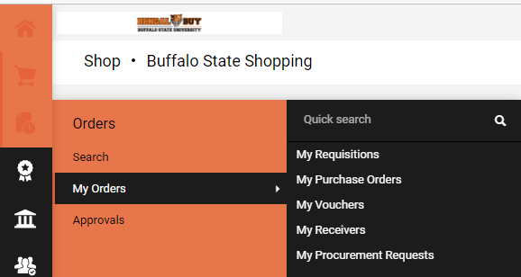
- Users can see requisitions, purchase orders, vouchers and receivers related to their orders.
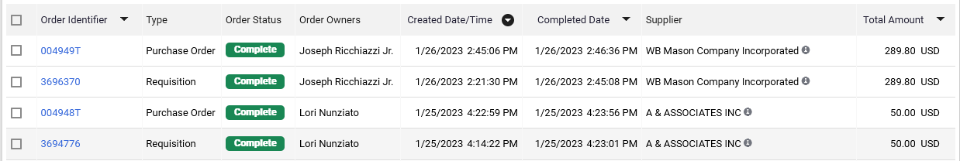

- If you click on the blue requisition number or PO number, you will be able to view the exact workflow with date and times to see where the order is, and whom it is with at what step of the workflow
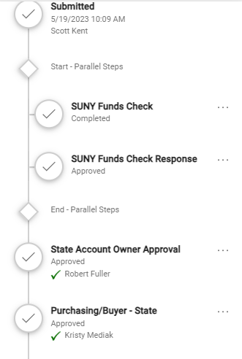

PO Distribution Status
Once a Purchase Order is created, it will be distributed to a vendor. By clicking on the Purchase order, you can see when the order was distributed on the Status Tab, under Document Status.
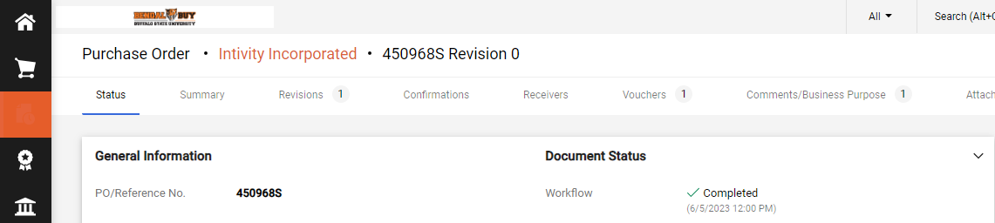
Order Acknowledgements
You will also be able to check the status of an order; if it has been received or paid from the PO by selecting the corresponding tab at the top to show the details.

Receiving
Within Bengal Buy, a receiving record must be created for all orders before payment can be made. The responsibilities for creating a receiver depend upon the nature of the order and who receives it.
- All commodities/services must be received by the department who received the goods/services.
- All Receivers need to be completed within 5 Business Days of goods received on campus or services being completed. This ensures timely payment to the supplier.

Creating a Receiver
- From Homepage, Click on the Accounts Payable Icon
- Click Receiver Menu
- Click Create New Receiver Menu
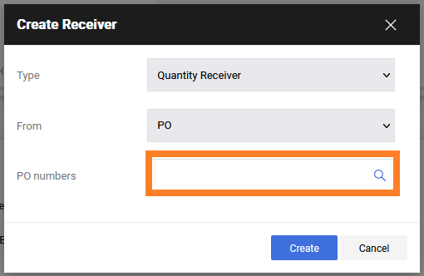
NOTE: It is best practice to create a receiver within 5 days of receiving an order.
- From Menu, use a “Quantity Receiver” for physical goods or software and from PO. Use a “Cost Receiver” for purchase orders that require services to be performed. Input PO Number on the packing slip or shipping label. Bengal Buy orders end with an “S”.
- Input data in the header section of the receiver.
  - Update Receiver Date to reflect the date shipment was received.
  - Note: If shipment was received the same day as the receiver created in Bengal Buy, you can leave as default.
  - Input Packing Slip No., if it exists.
  - Input any notes as necessary into the Notes field.
  - Scan packing slip and upload attachment by Attach/Link.
- Input number of items received into the Quantity field of the receiver.
  - Note: If this is a partial shipment, you should first click the Remove Line button in the Actions Section to remove any items that are not received in this shipment. A second receiver can be created when the additional items are received.
  - Inspect the shipment to confirm that all items were received and compare against packing slip if available. For each line item, input the number of items into the Quantity field.
  - Leave Line Status as Received, unless one of the following exists:
  - If an item has been returned or is anticipated to be returned, you must enter the quantity returned and update Line Status to Returned. You must also enter a reason in the Returned For Field and enter an RMA(Return Material Authorization) in the RMA No. field, if one was provided.
  - If the entire order, or part of the order was canceled, the Line Status should be updated to Canceled for any portions of the order that were canceled. Note: Please contact Purchasing when cancellations occur. Additional guidance will be provided on how to do this in Bengal Buy.

- Carefully double-check all receivers to make sure they are accurate. This is to ensure the integrity of the receiving record. If an error occurs in the quantity, a second receiver should be created to adjust the total. Please contact Accounts Payable via APtravel@buffalostate.edu and we will provide support for handling these situations.
- Once you have verified all information is correct and accurate, click Complete to finalize the receiver.
- The record is now in Bengal Buy, and additional receivers can be created for partial shipments or other orders.
- The PO will now show the receiver.

Creating a Change Order
If you have a situation where a Purchase Order must be changed, such as for an item that will no longer be needed, or additional costs need to be paid such as freight, a Change Order is necessary.
To create a Change Order, contact the Procurement Department who can assist with the process.

New Supplier Process
When entering a Non-Catalog order in the item pop-up window, enter the supplier by typing the name and then selecting from the options.
If the department cannot find a supplier in the Bengal Buy system, please follow the below
instructions:
- If the supplier you wish to use cannot be found when searching for Suppliers for Non-Catalog Item orders, type in “New Supplier” as the supplier, and the ‘Procurement (Internal) Fulfillment Address will populate as below. The department should attach the completed sub- W-9 to the requisition. If the supplier is a foreign vendor, please email Procurement Services department for processing. Please include all attachments from the vendor and comment that the New Supplier was used. Sub-W9 form can be obtained from the purchasing website.
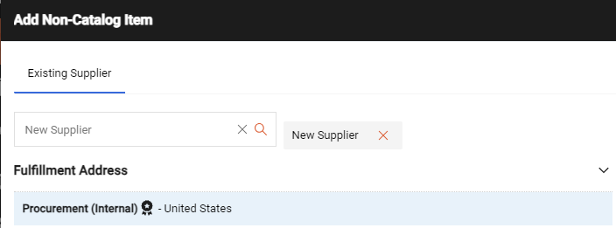

- Procurement Services will review and determine if the supplier/vendor is in FMS. If located in FMS or the supplier can be found, they should be activated or assigned to the campus in Bengal Buy. Once done, the department should be notified of the vendor’s name and that they are now available for use.
- If Procurement Services determines the vendors is not in FMS, they will enter the W-9 information into the SFS system then will be able to create a supplier in the Bengal Buy system. This is a one-time set up for vendors.

Tip and Tricks
- Please note all emails will come from DoNotReply@sciquest.com, to ensure you receive all applicable emails, add DoNotReply@sciquest.com to your contacts or address book. View your spam or junk to ensure no emails have been inadvertently delivered there.
- Be sure to include all attachments. Generally, all non-catalog orders will require an attachment to substantiate the price. Please ensure to follow the threshold guidelines.
- Make sure that attachments are coded correctly (e.g. internal vs. external).
- Use comments! This feature allows a more complete record of the purchase and allows you to share specific information that may be helpful when being reviewed. However, be mindful that all comments become part of the record and may be reviewed by auditors!
- Orders placed through Bengal Buy will have a requisition number and PO number generated automatically. These will be different, but all documents linked together.
- If you are an approver - be sure to assign the document to you before taking any action. You have more options for processing requisitions.
- If you cannot find a vendor, use the New Supplier* option or contact Purchasing. There is a one-time setup that needs to occur to get vendors into Bengal Buy.
- If you need help, contact us! Bengal Buy is a powerful, but complex program. Let us know what issues you are running into so we can help you.
- You will need to allow pop-ups from the system, otherwise punch-outs will be blocked.
- It’s considered best practice to create a receiver document within 5 days of receiving an item.
- Catalog items and Non-Catalog items cannot be purchased together in one cart. These must be separate purchases in Bengal Buy.
- When ordering via a Non-Catalog item, always select the bolded address if multiple are listed for a vendor.

Glossary of Terms
Hosted Catalogs: These are an electronic form of a supplier’s printed catalog. Suppliers provide information about the items that they sell on a spreadsheet. This information is the loaded into the application to be viewed by requestors as they shop. Normally, organization specific pricing is applied to a host catalog.
Non-Catalog Items: A non-catalog item indicates the item is not available via hosted catalog or punch-out catalog. A user is required to accurately describe the item, completing fields of information on a form such as supplier, item description, catalog number, UOM, price, quantity, and other criteria that provide an approver with enough data to decide on the requisition.
Requestor: These users can shop for items and submit carts
Approver: These users can review (approve, return or reject) purchase requisitions assigned to them.
Purchase Requisition (PR): Once a cart is submitted, it becomes a Purchase Requisition (PR). Funding for the Purchase is oftentimes validated (valid account entry and available account funding). Once a Purchase Requisition is fully approved and complete it becomes a Purchase Order.
Purchase Order (PO): A Purchase order is an order to purchase goods or services. A purchase order can be considered a binding contract. It contains the name and/or description of the goods you are buying, as well as the quantity, price, payment, and delivery terms. Many suppliers, distributors and vendors will insist on a purchase order before they sell to you.

